B39SB Time and Frequency Signal Analysis – Tutorial 5

P1. Two LTI systems are arranged in series with and . Find the impulse response of the entire system.

P2. An active filter has the transfer function . For what values of k is the filter stable?

P3. (from Alexander-Sadiku textbook) . Find for .

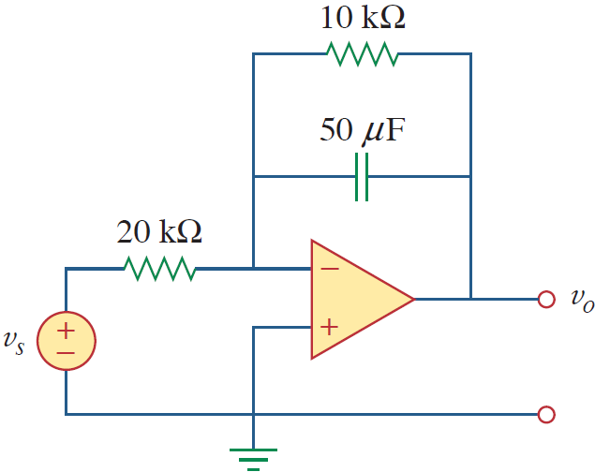

P4. The transfer function of a circuit is given by .
(a) Find the frequency response (magnitude and phase response) of the system at an angular frequency of 15 rad/s. Find the output when (b) the input is 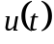; (c) the input is .

P5. (from Alexander-Sadiku textbook) Find .

